Autumn Holidays

1st week

class 1 - 4

12.10.-16.10.26

Autumn is coming

Monday Train your skills (ADAC bike parcours on the schoolyard)
Bringe gern dein eigenes Fahrrad und einen eigenen Helm mit!
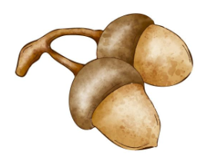
start: 9:00 am
price: 0,50 €

afternoon: class 1: relax time
class 2-4: town, name, country game

Tuesday Hike & collect (Gründelpark Glauchau)
start: 9:00 am

price: 1,00 €

afternoon: class 1: relax time
class 2-4: caterpillar race

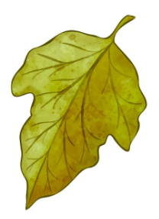
Wednesday Cozy lightning (handicraft)
start: 9:00 am
price: 1,00 €

afternoon: class 1: relax time
class 2-4: gym


Thursday Yummy sandwiches (cooking)
start: 9:00 am
price: 4,00 €

afternoon: class 1: relax time
class 2-4: outdoor games

Friday Fit & fun (gym)

start: 9:00 am
price: 0,50 €

afternoon: favourite toy

Bitte jeden Tag Sportsachen mitbringen.
- Änderungen vorbehalten! -

