Autumn Holidays

2nd week

class 1 - 4

19.10.-23.10.26

The colours of autumn

Monday Colourful bookmarks (handicraft)
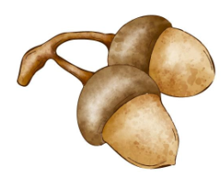
start: 9:00 am
price: 0,50 €

afternoon: class 1: relax time
class 2-4: read & relax

Tuesday Slimy and explosive (experiments)
start: 9:00 am

price: 1,50 €

afternoon: class 1: relax time
class 2-4: games in the gym


Wednesday Crazy rollerblades (Unterstadt Glauchau)
start: 9:00 am
price: 0,00 €

afternoon: class 1: relax time
class 2-4: autumn mandalas


Thursday Movie time (Clubkino Glauchau)
start: 9:00 am
price: 4,00 €

afternoon: class 1: relax time
class 2-4: bingo

Friday Creative holiday ending

start: 9:00 am
price: 1,00 €

afternoon: favourite toy

Bitte jeden Tag Sportsachen mitbringen.
- Änderungen vorbehalten! -

